**Oozie Email Action**

The email action allows sending emails in Oozie from a workflow application. The email action is executed synchronously, and the workflow job will wait until the specified emails are sent before continuing to the next action.

**SMTP server Configuration in Oozie**

The email action requires some SMTP server configuration to be present (in oozie-site.xml). The following are the values:

oozie.email.smtp.host= The host where the email action may find the SMTP server (localhost by default).

oozie.email.smtp.port= The port to connect to for the SMTP server (25 by default).

oozie.email.from.address= The from address to be used for mailing all emails oozie@localhost by default).

oozie.email.smtp.auth= Set it as false

**Steps:**

1. Modify the oozie-site.xml for the oozie to send mail notification to the specified email addresses
   1. Go to Ambari UI
   2. Click on the Oozie services and modify the below configuration

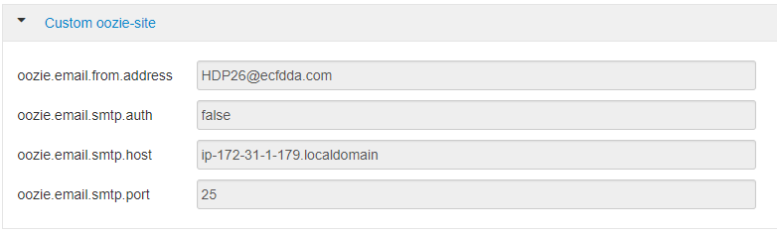

1. Once the changes are done, restart the Oozie services from Ambari UI